
W5 - PRACTICE
JSX - Dynamic Data - Components

 At the end of this practice, you should be able to…
✔ Create a new component from HTML
✔ Translate HTML to JSX
✔ Understand the basic of nested components
✔ Draw a diagram component from some given code
✔ Understand how to display data dynamically using curly braces {xx} in JSX

 How to work?
✔ Download the start code from the Google classroom
✔ For each exercise you can either:
- Run npm install
- Or move an existing node_modules to the exercise folder (fastest option!)

 How to submit?
✔ Create a repository on GitHub with the name of this practice: Ex: C2-S1-PRACTICE
✔ Push your final code on this GitHub repository (if you are lost, follow this tutorial)
✔ Finally, submit on Google classroom your GitHub repository URL
Ex: https://github.com/thebest/ C2-S1-PRACTICE.git

 Are you lost?
You can read the following documentation to be ready for this practice: https://www.w3schools.com/react/react_jsx.asp https://www.w3schools.com/react/react_props.asp https://www.gatsbyjs.com/docs/how-to/images-and-media/importing-assets-into-files/


Your task is to create your first React component!

You have an App component, containing the header and the body.
- Create a component Header containing the header of the file.
- Change the code in the App component to use this new component

Notes:
- You can create the component directly in the App file.

The finished app could look like this:
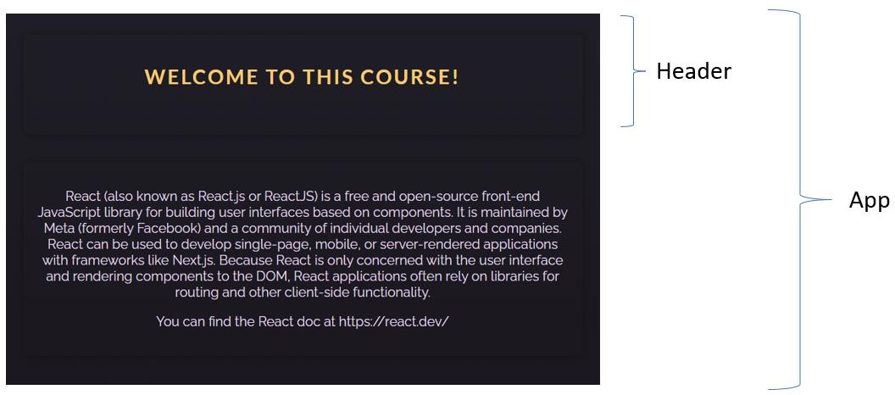
The finished app diagram component:
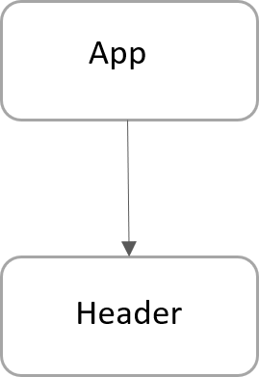

Well done!
Now your challenge is to convert some vanilla HTML into some React JS code!

Q1 – Research on internet and list down the main differences between HTML and JSX syntax
-
-
-

Q2 – The first part is to create an empty React project which display Hello

- Create a new React project using the following command:
npm create vite exercise2 -- --template react

- On the root folder, remove the following useless file:
.eslintrc.cjs README.md
.gitignore

- On /src folder remove, remove the following useless file:
/assets App.css

- Edit the index.css and remove all styles
- Edit the App.jsx and just write a simple code:
function App() { return (
<>
<p>Hello</p>
</>
);
}
export default App;

- From the root folder, launch npm install and npm run dev
- You have now a very simple ReactJS code that displays Hello:



Q3 – On this second part you need to adapt the original HTML code to your new created project:

Your code should be composed of 4 components, as bellow:
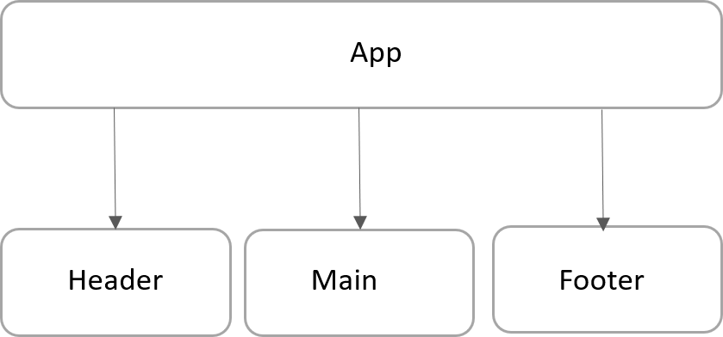

- Create a folder /components
- In this folder create 3 additional JSX files:
  - Header.jsx
  - Main.jsx
  - Footer.jsx

- Adapt the code from the original HTML code to those 4 compomers (App, header, Body and Footer)
  - Do not forget to export your components to use them outside!

- Finally, you can copy the original CSS code to your new project

The finished app could look like this:



Amazing!

Q1 - Now your challenge is to draw a diagram component from some existing React JS code.
- Read the code
- Identify components
- Draw the diagram component (using power point or another tool)
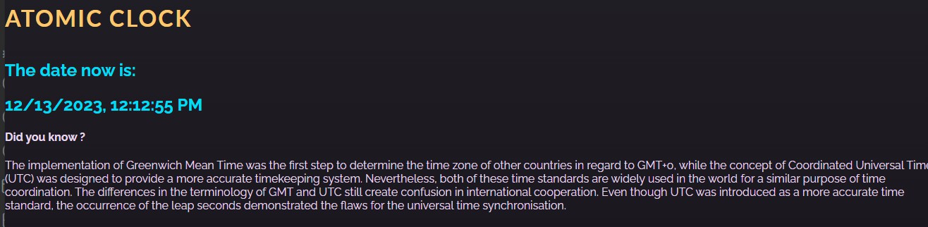

Q2 – Let’s play with dynamic data:

  - In Header, change the title to: “The amazing atomic clock”

  - In Time component, change the code to display only the time only (not date + time)
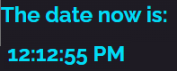

Amazoooome!
For this last exercise, your challenge is to provide the dynamic data for the 2 following fields:
  - The value (15 dollars) converted in Dong
  - The value (15 dollars) converted in Euro

Important
  - You need to implement and call the functions already provided for you to convert dollar to other devices
  - All inputs are disabled: we use them for display only, not to enter any value…

